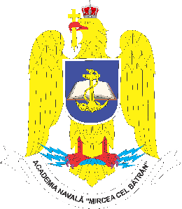

MIRCEA CEL BĂTRÂN NAVAL ACADEMY
1st Fulgerului Street, 900218, Constanta, Romania
Tel: +40-241626200
Email: erasmus@anmb.ro

NOMINATION FORM
Sending institution
Contact person
Contact person email

No. | Last name | First Name | Student email | Exchange period* | Study field | Level of study

*Mobility period: please, specify the duration of the exchange period:
- Autumn semester;
- Spring semester;

SIGNATURE
For the sending institution

